Case 1

A 62-year-old lady attended your AED for dizziness and generalized weakness for 1 day. She was fully conscious. Her blood pressure was 160/78mmHg and pulse was 78bpm. 4 limbs power 5/5. When examining on the presence of nystagmus, you saw this
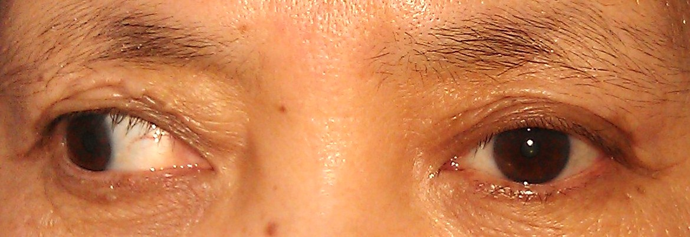

Q1. Describe the eye position(1).What is this clinical condition (1)?
Q2. What does the nerve supply (3)?
Q3. Give 4 causes of the above condition (2). How to distinguish medical and surgical causes of the condition (1)?

The patient was admitted to medical ward and later developed ataxia and absence of knee jerk and ankle jerk.

Q4. What syndrome is characterized by triad of ophthalmoplegia, ataxia and areflexia (1)?
Q5. If the patient develops bulbar weakness with swallowing disturbances, severe tetraparesis or respiratory failure, what treatment (other than supportive) can be given (1)?

Case 2

A 71-year-old man was found lying on floorof kitchen with confusion. He was suspected to take 40mls of 拳頭油(39% wintergreen oil) about 6 hours ago.His GCS was E3V1M5, blood pressure 154/90, pulse 100/min, respiratory rate 28/min, SpO2 100% while on 2L/min oxygen, temperature 35.4ºC. Here attached the medicinal oil photos and his ABG result.
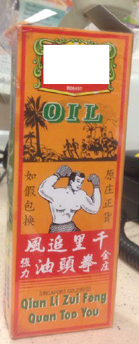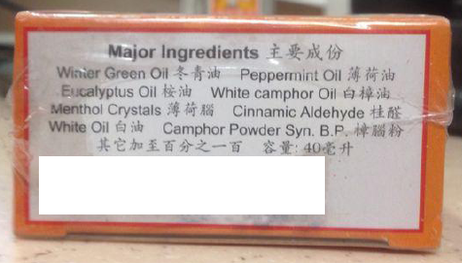
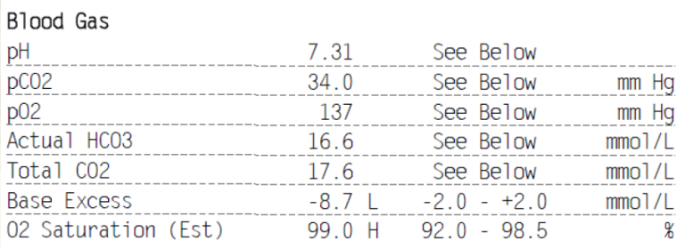
Q1. What is the patient suffering from? (1)
Q2. Name 3 investigations in A&E and the respective reasons for the investigations (3)
Q3. Name the gastrointestinal decontamination method(s) that may be used in this patient. (1)
Q4. What is the recommended drug that may help this patient and the purpose of giving this drug? (2)
Q5. Name one treatment for this patient if the above measures fail. (1)
Q6. What other ingredients of this medicinal oil can also contribute to CNS toxic effects? (2)
Case 3

A 73-year-old man attended an A&E Department for left sided low back pain for one week. He claimed that he might have lifted heavy weights before the onset of the pain.X-ray of lumbosacral spine was done.The pain was relieved by an injection of NSAID (Toradol).
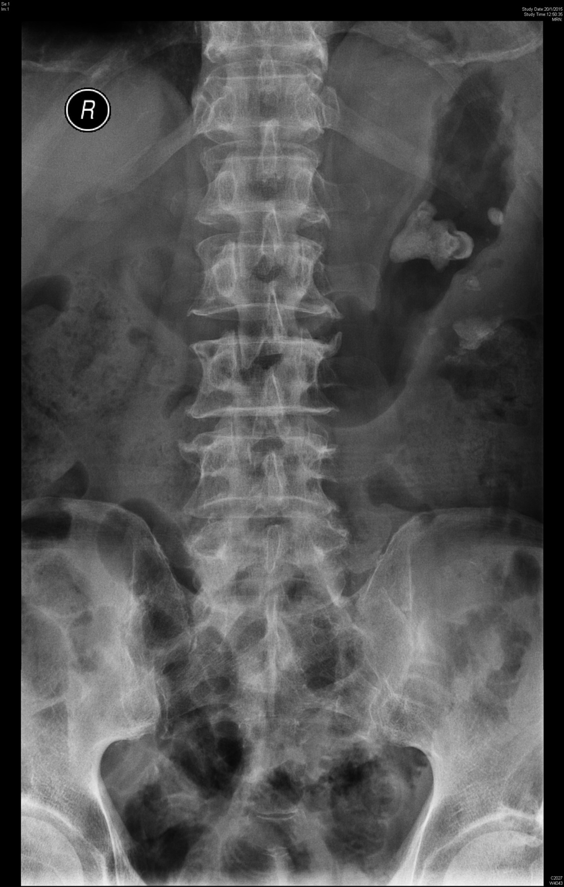
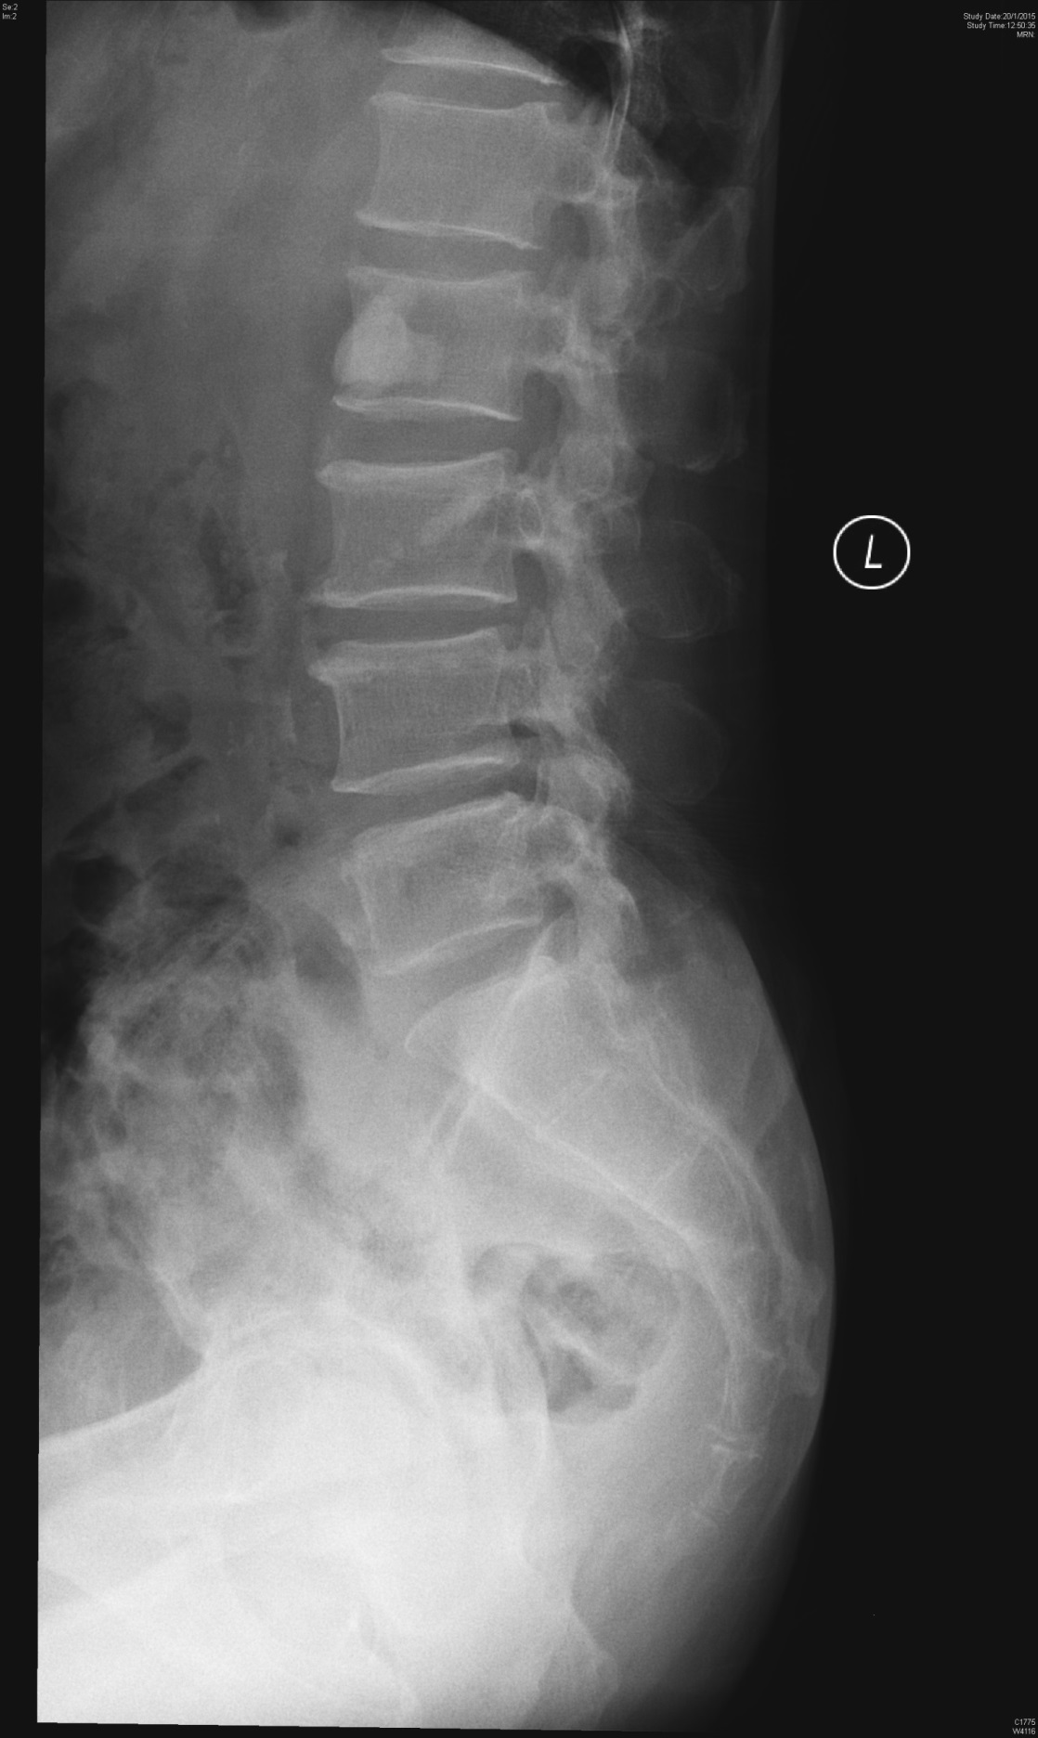
Q1. What are the radiological findings of the X-ray ? (2)
Q2. Name two investigations in A&E that might help you determine the urgency of his problem. (2)
Q3. Name two classes of drugs you might give to the patient on discharge. (2)
Q4. Name two conditions that might precipitate the problem in the patient. (2)
Q5. Name two definitive treatments for his problem other than open surgery. (2)

Case 4
This question is about called back patients.

A 43-year-old taxi passenger at back seat was sent to the A&E Department by ambulance after a traffic accident. His forehead hit against front seat when the taxi braked suddenly. He was fully conscious with laceration wounds on left side of forehead. The wounds were closed. Skull X-ray was done as shown and was interpreted by the case doctor as unremarkable. He was then discharged with head injury advice.
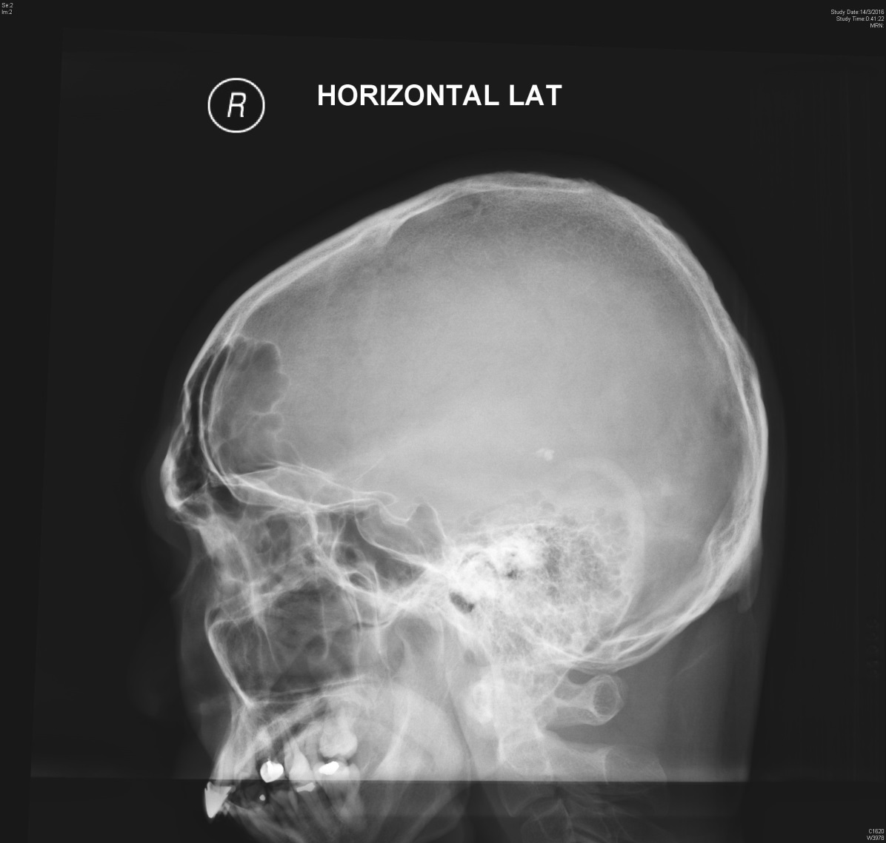

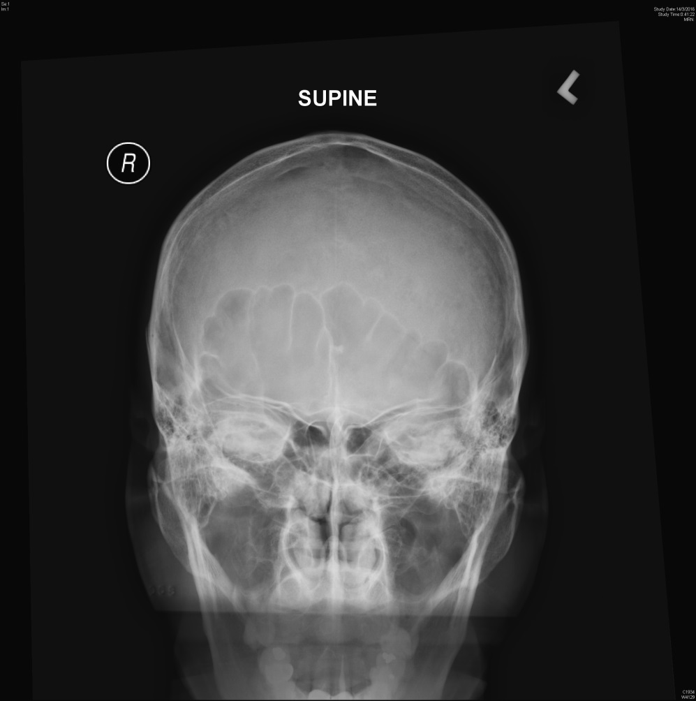
The X-ray images were later screened by senior doctor and the patient was called back for further management.
Q1a. What is the missed X-ray finding? (1)
Q1b. What further investigation would you like to do? (1)

A 52-year-old female was hit by a wooden board at her left face. Physical examination found bruise over her left infraorbital area. X-ray of orbits were done and found no fractures by the case doctor. She was discharged with pain killer.
She was called back after X-ray screening.
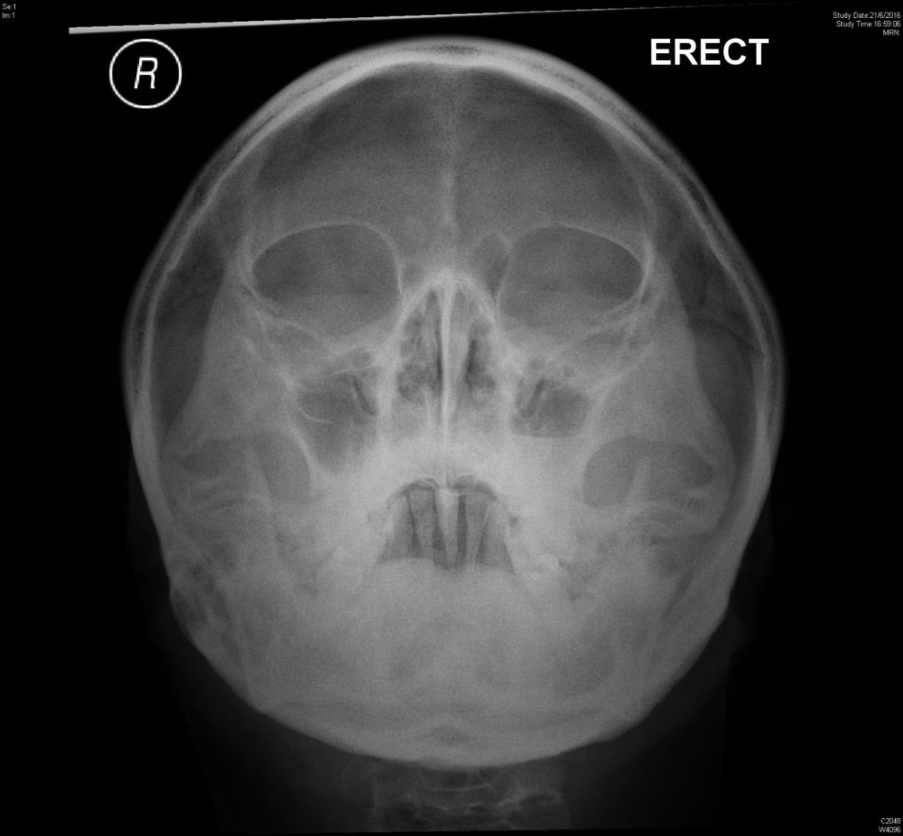
Q2a. What is the missed radiological finding? (1)
Q2b. What eye sign should be excluded? (1)
Q2c. Which nerve should be examined carefully in this patient? (1)
Q2d. What further investigation would you like to do? (1)

A 5-year-old girl with good past health attended A&E Department for fever of one day. She had some cough and sore throat. Chest X-ray was done and found clear lung fields by the case doctor. She was discharged with symptomatic treatment for upper respiratory tract infection.
She was called back for further management after X-ray was screened by senior.
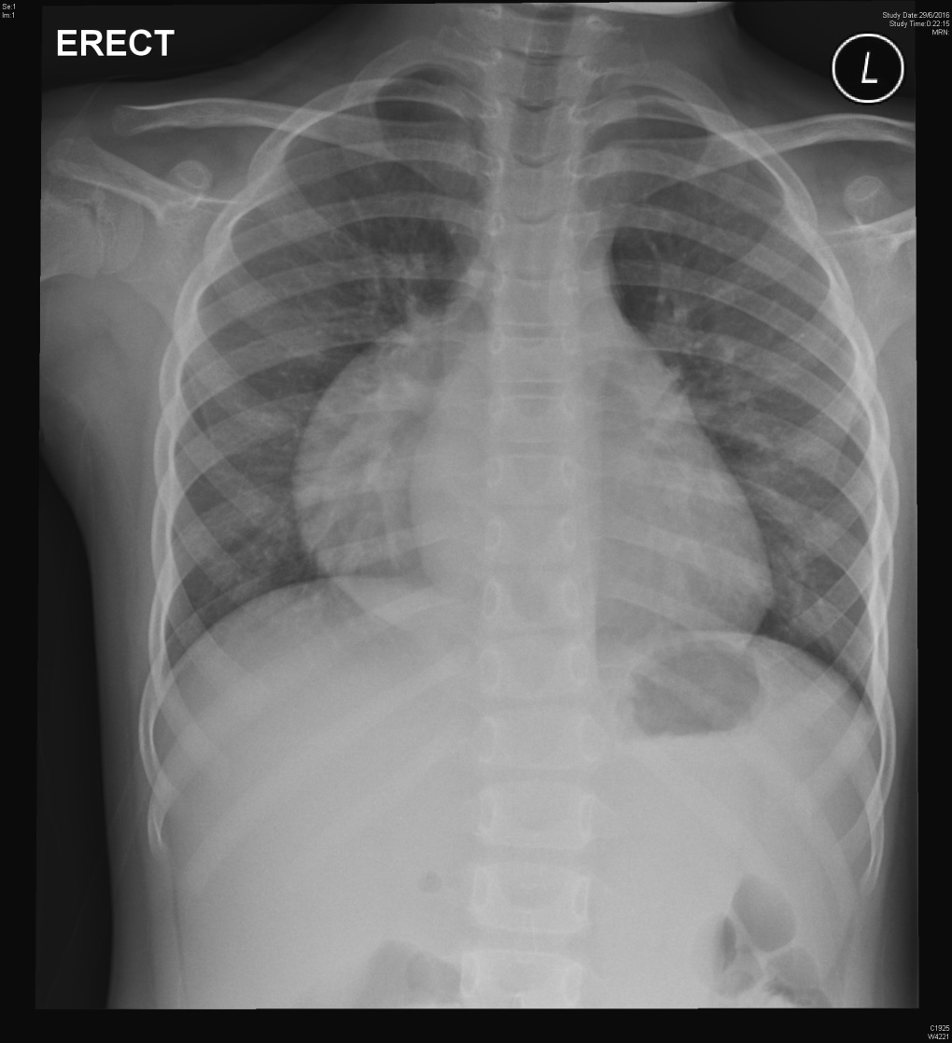
Q3a. What is the missed X-ray finding? (1)
Q3b. What further investigation can be done in your A&E Department to confirm your finding? (1)

A 52-year-old female sprained her left foot when she fell downstairs on 4-Jan-2016. There was pain and swelling at left foot dorsum and she had difficulty to bear weight on left foot. X-ray of left foot was done and found unremarkable by the case doctor. She was discharged with pain killer and advice on R.I.C.E therapy. She re-attended A&E for few more times for persistent left foot pain and swelling on left foot dorsum in the next 6 weeks. She was finally admitted to Orthopedic Ward with operation done.
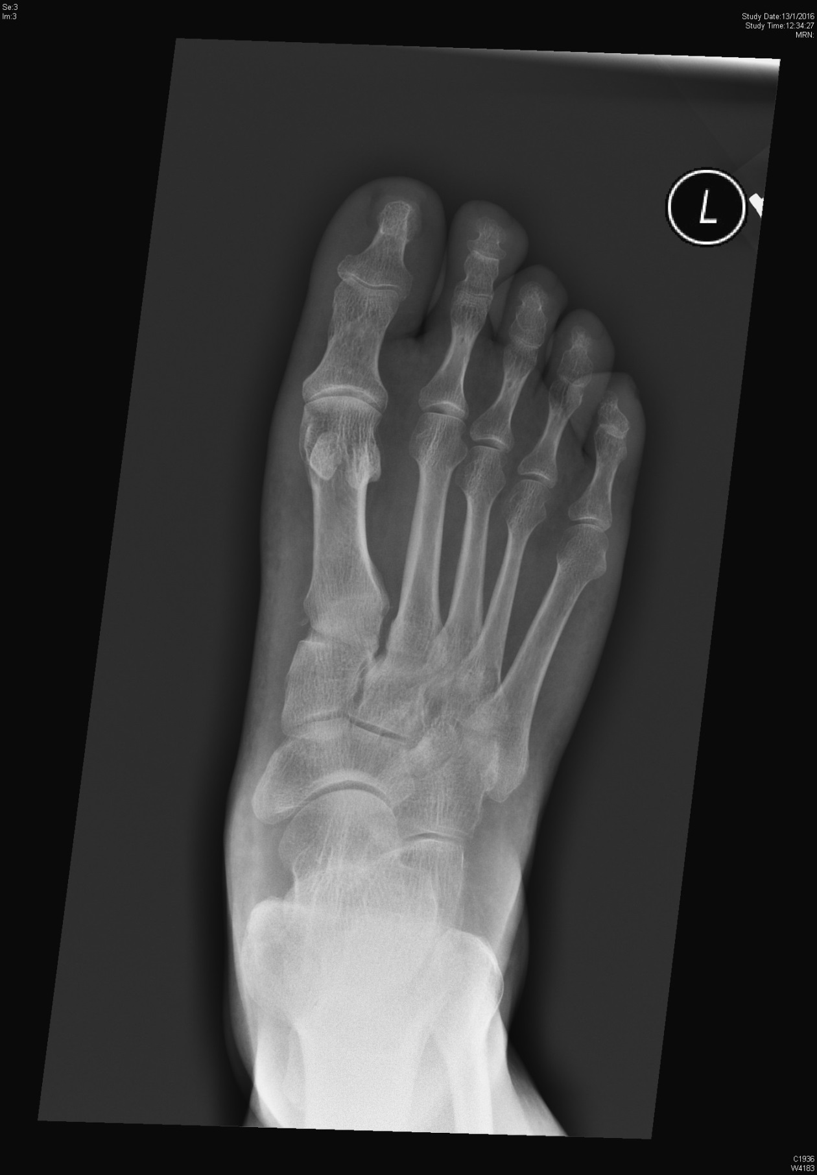
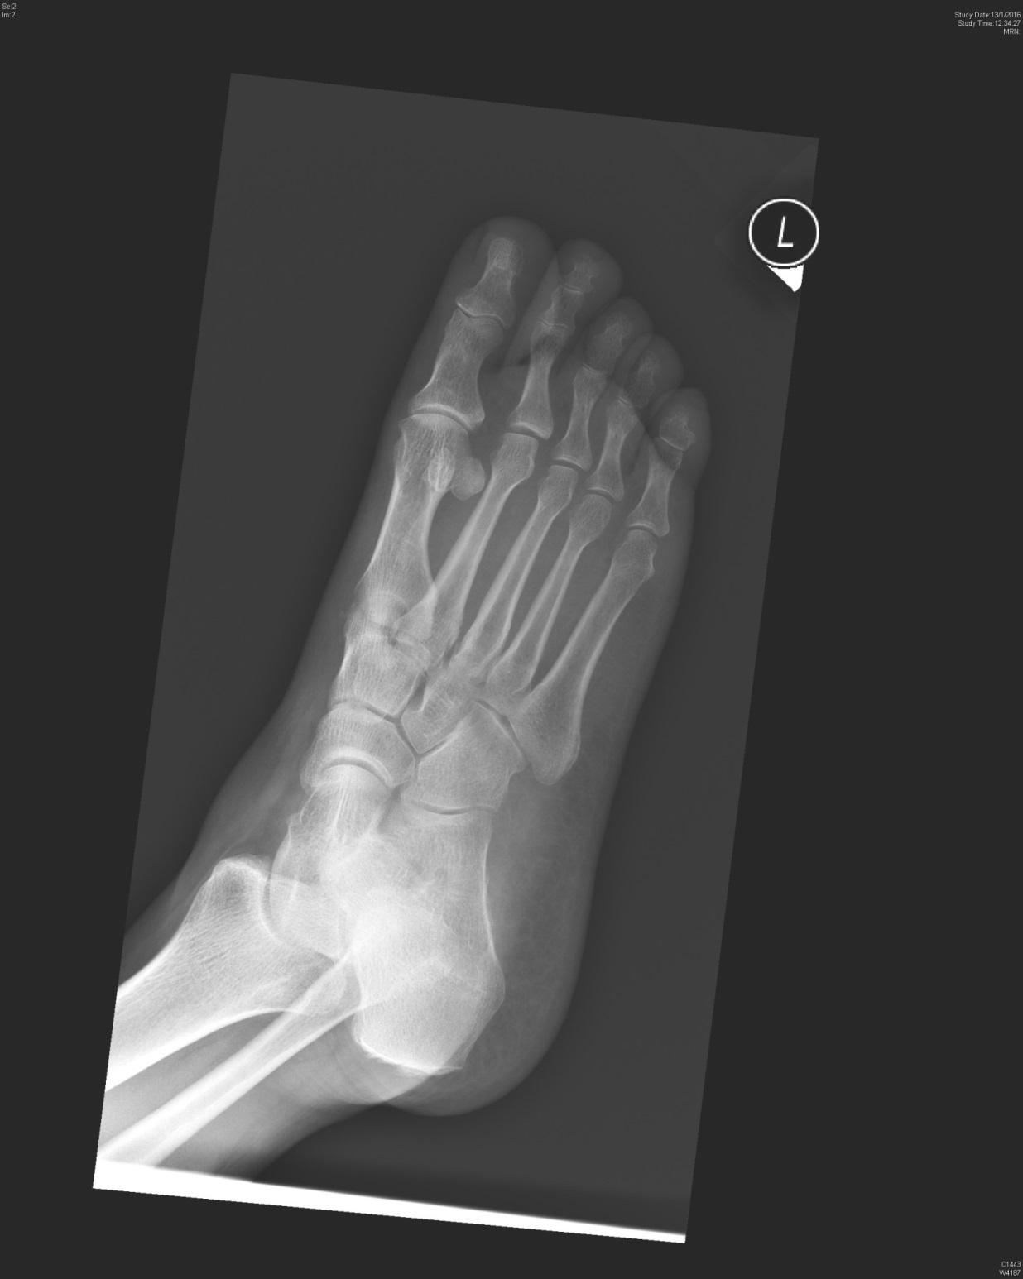
Q4a. What is the suspected missed X-ray finding? (1)
Q4b. What is the likely diagnosis that requires operation in this patient? (1)

